**Setting up Ansible**

Let's start by setting two EC2 (UBUNTU 22.04 ) with the same configuration. One of them will be our controller and the second one will be a node.

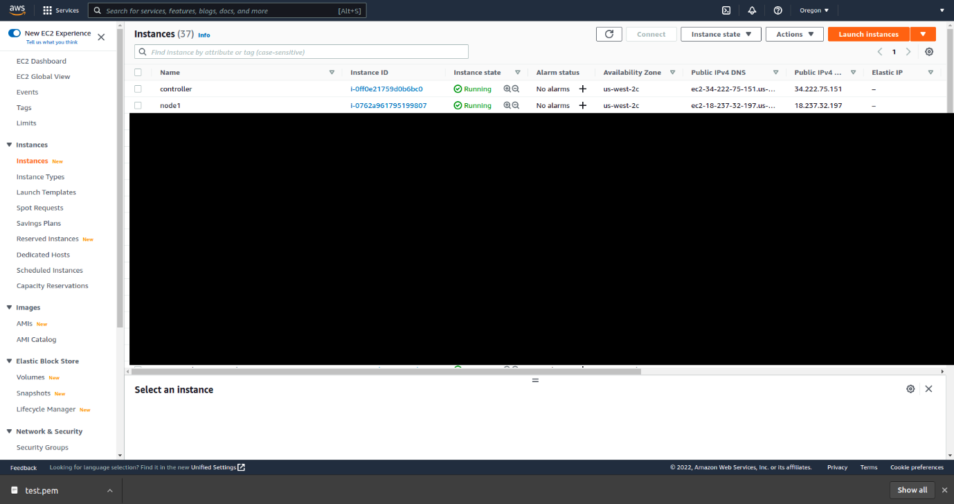

The first step is to get the PEM keys for the servers. For simplicity, I use the same one for both. Once downloaded, I saved it and change the permissions.

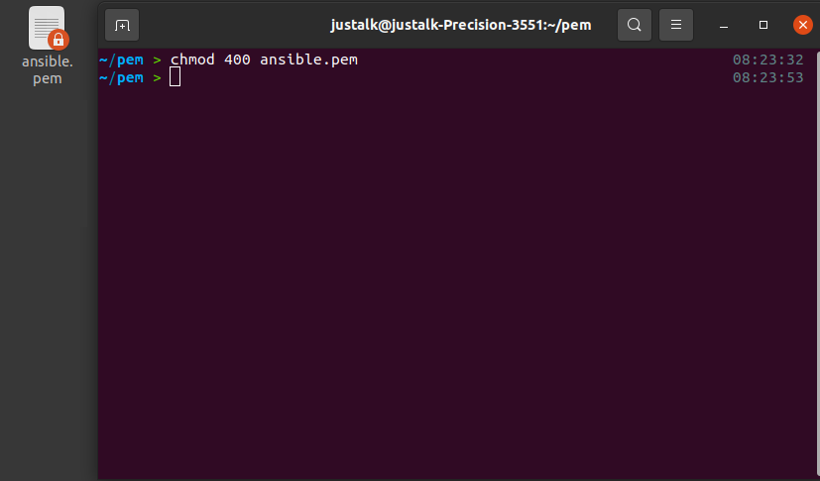

For simplicity, I also setup aliases for connecting either to the controller or the node without tying the full ssh command.

And before going further, let's end that with the installation of ansible.

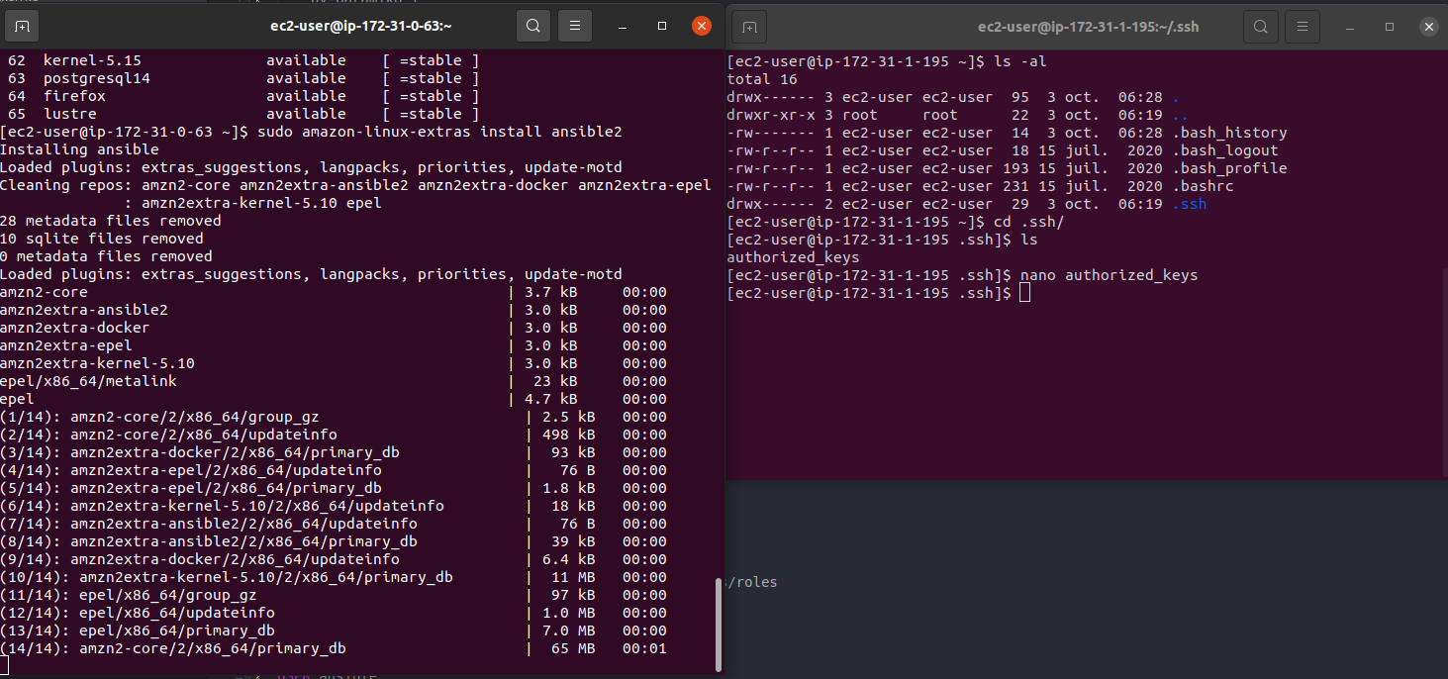

I can switch to my ansible user and check if ansible has been installed properly.

Install ansible

$ sudo apt update

$ sudo apt install software-properties-common

$ sudo add-apt-repository --yes --update ppa:ansible/ansible

$ sudo apt install ansible

$ ansible --version

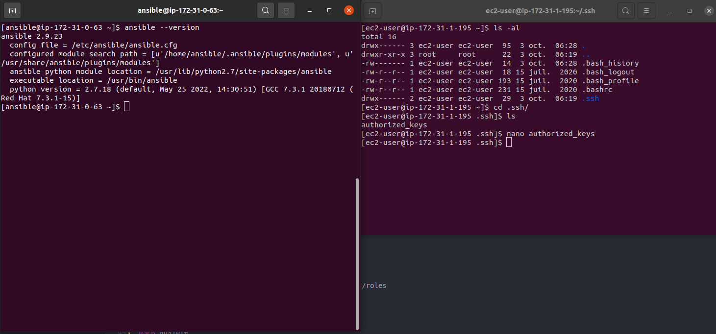

**Using Ansible**

I will now save the pem file on my controller server. For this either use scp or just create a new file and fill up with the private key.

$ touch aws.pem

$ vi aws.pem

Let's create our inventory with our node. At this step and just for fun, I added another server so you will see how it is to setup for multiples host.

$ vi ./inventory

Where I filled up the following content:

[nodes]

ec2-18-237-32-197.us-west-2.compute.amazonaws.com

ec2-54-214-124-124.us-west-2.compute.amazonaws.com

[nodes:vars]

ansible_user=ec2-user

ansible_ssh_private_key_file=/home/ansible/aws.pem

**RUN AND CHECK CONNECTVITY**

ansible -i inve.txt all --private-key=aws.pem -m ping

And finally, I created my playbook with the content under.

$ vi ./book.yml

--- # Do things on node

- hosts: nodes

become: yes

tasks:

- name: install git

yum:

name: git

state: latest

And I am now ready to test using the ansible command.

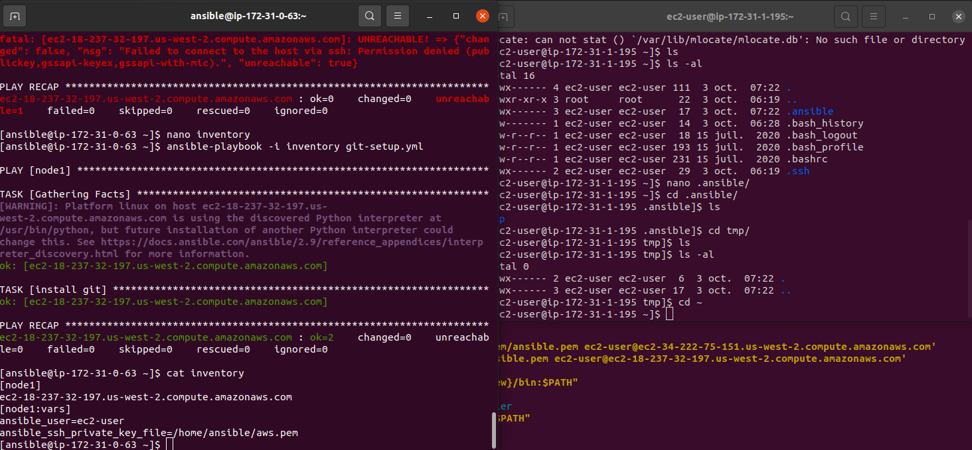

And voila! Git has now be installed on our node server.